WHAT THE JUDGEMENTS MEAN TO BOATERS

Contrary to the CART Press Release and Commentary, the Appeal judgement [2013] means a great deal to all boaters of whatever sort. The previous High Court judgement [2012] meant less for the generality insofar as navigation rights were concerned, because that accounts for only some 12% of the relevant waterways. It did, however, establish some cardinal principles of engagement and criticised the management in such a way and to such an extent, that any ordinary organisation would be humiliated.

So that is one aspect of what both judgements mean to boaters – that they give you a handle wherewith to defend against inappropriate behaviour, excess zeal and unbridled assumptions of power and authority and learning; they have been rapped on the knuckles for behaviour very publicly, and will be none too keen to repeat the experience – but you will still need to rub their noses in it from time to time.

That defensive value aside, I will deal with both judgements as to what your active rights are, following the determination that you have a liberty to enjoy the waterways in all ways not prohibited by statute.

But also, it would be inappropriate not to make the point that there is a price for such liberties as we enjoy to date - and that price is equally a matter of interest/concern. I have little interest in damaging either the organisation entrusted, however unwisely, with running the waterways, or the community of boaters using them, and this session is not designed to be an authority-bashing one; rather it is intended to provoke a little thought and debate and hopefully a consensus of behaviour that is [theoretically at least], designedly an important element of the “new” constitution of the waterways authority, supposing you believe that that is what we now have – and in any event, is something we can hopefully work towards once/if the old-guard upper echelon of executives have sloped off to milk more profitable pastures new.

- When you need or do not need boat licences
- Where and when and for how long you can moor along the waterways
- What you do and do not need to pay for
- What you can expect in way of treatment from the authority
- How Human Rights affect the issues
- Whether you should litigate

When you need or do not need boat licences

You need a boat licence for all waterways where the public right of navigation came into existence only by virtue of an Enabling Act; if a canalised river had previously been navigable in the legal sense, then the public rights were unaffected.

Where Public Rights of Navigation subsist, only an express Act of Parliament can remove them or modify them; in 1971 a selection of BW’s river waterways had the same imposition of registration requirements as had shortly before been imposed upon the upper Thames. It is still open to boat owners to moor outside of the main navigation channel free from the requirement for a pleasure boat certificate – but of course, if you wish to use the river at all you will need to get a certificate, and if you wish to travel beyond that river onto the canals you will need the standard pleasure boat licence.

The scheduled rivers of 1971 were added to by a further Act in 1974, and still further by the 1995 Act. There remain many miles of navigable rivers under BW control where no licence is required whether you use or simply keep your boat on them.

If you are on offline - but - connected waters, such as with certain private arms and lakes, or marinas, then you don’t need licences either – but you will find that BW have imposed on most owner/operators of such waters a contractual obligation to require all their boats to be licensed even if they don’t venture onto BW waters. That is not legal, but it is removed from your control [unless you are one of the relevant owner/operators], so there is nothing you can personally do about it; the moorings providers are entitled to impose whatever conditions they see fit for their facilities, and if they’ve knuckled under BW/CART’s arm-twisting bluff, then there is no recourse.

Where and when and for how long you can moor along the waterways

So long as BW/CART’s statutory powers are concerned: you can moor anywhere you like along the public towpath, subject to the restrictions of Byelaws 28 and 29. You cannot legally moor to the offside anywhere, where that is private property, unless you have the owner’s consent.

Those who have a regular “home mooring” whether their own or rented, are entitled to keep their boats there as long as they like, with the usual provisos. They may leave their boats elsewhere on the system while travelling away from their Home Mooring, for as long as they like with the usual provisos.

Those who do not have Home Moorings may moor for up to 14 days in any one place anywhere along the towpath subject to the usual provisos, “or for so long as is reasonable under the circumstances”.

Whether you are moored to a private offside mooring or to a public towpath mooring, you are subject to the powers of both s.18 & 19 of the 1995 Act – whereby BW can shift you without notice if you are causing an obstruction or shift you temporarily to enable bankside maintenance work.

What you do and do not need to pay for

BW/CART are bound by the terms of the original canal Enabling Acts to the full extent that those have not been expressly modified by later, modern statutes. Whatever was expressed to be free from charge in those Acts, remain free from charge today except where expressly over-ridden..

The 1962 Act did not create new rights for BW to charge for and condition uses of the canals and facilities; what it did was to modify the existing rights to charge, which were a fantastic medley of disparate methodologies. In order to simplify and homogenise the charges schemes, section 43 of the 1962 Act was drafted to remove any existing caps on the level of charges, and remove any specific limitations to the terms of use relating to the various facilities for which they could charge.

What you can expect in way of treatment from the authority

Well, I am afraid you can expect anything and you should be at least aware of that. I won’t say that there is nothing to which they will not stoop, but it’s close to that, and belief otherwise is dangerous naivety.

Yes; you have what the law knows as “Legitimate Expectations”, but as Mr Justice Hildyard found, those can and will be violated if it suits them. The judgements mean only that you can wave that finding in their faces – for all that they care; but it’s something, I guess.

Their approach is exemplified and highlighted by the content of the new draft byelaws which Nigel Johnson had drawn up to earn his bonus for the year in which he approved the actions taken to expel us from the waterways. Back in 1954 the powers to make byelaws under Part III, s(2) of the British Transport Commission Act were expressed to be for the purpose, not only for “regulating the use of the canal”, but for “regulating . . . the conduct of all persons (including the officers and servants of the Commission) who shall be on the canal . . .”

Well Mr Johnson was certainly keen to see that the “officers and servants” were treated with respect and courtesy – draft byelaw No. 88 deals with “Obstruction of BW’s employees, offensive language, behaviour etc”. But the content of the comment column is riveting – “It is not possible to include a byelaw that addresses offensive behaviour etc towards members of the public (as opposed to a BW officer/servant) as this is a general criminal law issue and outside the scope of the byelaw enabling powers.”

Go figure, as they say. So they want it to be a criminal offence for us to be rude to them, but it’s simply not possible under the 1954 Act to impose reciprocal restraints on them?! I always knew that we had different tints of glasses when reading the relevant statutes.

In the event that CART ever try to go down the route of having these byelaws approved, be very aware of such content – and be prepared to savage them before government in the hope that the MP’s will have something like the extreme conscientiousness of the 1993 Select Committee who wrestled with BW’s 1990 Bill.

Apropos – the mooring provisions of that Bill, which Parliament rejected, are there in the draft byelaws, with CART hoping for ratification in a second, renewed attempt to have these imposed as criminal offences.

How Human Rights affect the issues

This was one of the unsatisfactory elements in the judgements to my mind. Perhaps for the first time, an authority of this size was declared in violation of human rights – but so what? They evaded consequences by reason of the wrongful decision in the High Court, with the consequences not rectified on finding the High Court wrong.

At least it sets some sort of precedent, such that if a similar situation crops up again, you will be able to make a lot of hay with it.

Whether you should litigate

You may not, of course, be given a choice in the matter, even if you wish to concede and pay up and/or do whatever they want. Remember that we were section-8-ed because we were unlicensed, and yet they continued to pursue the notices against the 3 boats that voluntarily obtained licences; they were not going to let up just because we had complied with the claimed requirement.

Usually, however, as would have been the situation in our case, they would be happy for you to pack your bags and get yourself and your boat out of their hair. Many boaters have expressed themselves, indignantly, of the opinion that I should have done just that instead of “freeloading”, as they saw it, off their beloved masters.

But supposing that you wish to defend yourself because you believe the authority is demanding something to which you believe they have no entitlement; there are a number of factors to be borne in mind.

I don’t refer to these by way of dissuading you, rather because you need to be armed with an accurate appraisal of the costs and consequences - both inescapable and potential regardless of whether you wind up winning or losing.

Never relax into a frame of mind that lawsuits can be won, if you are only right; that “truth will out”; that “justice will prevail” – even the most tenacious can fall foul of tactical processes and manoeuvres – I’ve seen it happen and it still is happening in precisely the same area on the same facts, and the other boater is still flailing around with scant if any remedy. He is no less tenacious [probably far more so] and has the benefit of at least some legal training, but just because of some manipulated case management, his identical case was lost and he became branded a “vexatious litigant” unable to have recourse to the courts except upon the express permission of the judge who so branded him.

I’m painting a bleak picture of the judiciary, because no-one should entertain illusions about it, or have false hopes that it is the answer to any problem with authority – it IS the authority for all practical purposes, and has a crucial investment in the status quo; it IS, for all protestations of independence, a crucial part of and tool of, the government. The one instance where its independence will be vehemently asserted by the courts will usually be in circumstances where government seeks to minimise the importance and/or effect of this tool.

On the other hand, as a great philosopher once said – “give me a lever long enough, and I will move the world”; it is finding the leverage that makes the vital difference, and in the end, it was my finding that leverage that meant BW lost the case.

Put another way – it has certainly seemed to me, that the judiciary felt bound and determined to find in BW’s favour despite every argument to the contrary, and that only at the last, when confronted with the potential loss of a keystone of their own sources of power, did they reluctantly concede the position.

At the end of the day, however, we are dealing with a relentlessly litigious authority who will always find funds to pursue the most trivial of causes, regardless of how deleterious that is to the budget for the maintenance of the physical infrastructure. You need to be prepared.

The flip-side of the coin

What the judgements mean in terms of our own responsibilities. These could be said to be
classified as twofold:-
        - How we should behave on our own recognisance
        - How we should or should not react to others

Self-governed actions

A constitution such as the English one is a rare thing. Bagehot in his respected book on The English Constitution analyses the various principles of government underlying the European and American nations [as they were in the 19thC] and concludes that each is formed by and befitting the essential national characteristic of those nations.

The notion of libertarian freedom from constrictions of law requires a certain attitude of the populace for the philosophy to work at all. I want to briefly show a fundamental principle of the law’s application which has imbued the courts as our history has progressed.

Remember the spoof case cited by Lord Justice Mummery in the Appeal judgement? The judge in that fantasy case responded to the proposition [upheld in my judgement] that all is lawful where no prohibition exists, by saying: “ it would be idle to deny that a man capable of that remark would be capable of the grossest forms of licence and disorder.” It’s a common perception, and of course contains a strong element of reality; human nature being what it is, liberties will be abused.

We have looked briefly at the libertarian philosophy of the English Constitution and seen that it was and is purportedly founded on so-called Christian principles of social governance. Some answers to the appropriate conduct of the members of such a constitution can therefore be looked for in the alleged foundation document.

Biblical origin

There a few appropriate quotes, but I’ll choose just one – from the epistles of Peter, who exhorted his listeners to act: “As free, and not using your liberty for a cloke of maliciousness, but as the servants of God.”

English Case law - Woods B

And we see a direct reflection of this wording, as we might expect, in applications of the English common law. The philosophy as applied to moorings within the English law context is first, and famously, found in a footnote to an 1808 case regarding moorings on the River Tweed. It is the first of those I brought up in the appeal, and you may recall the judge’s reference to it. I’ll quote the case in full:
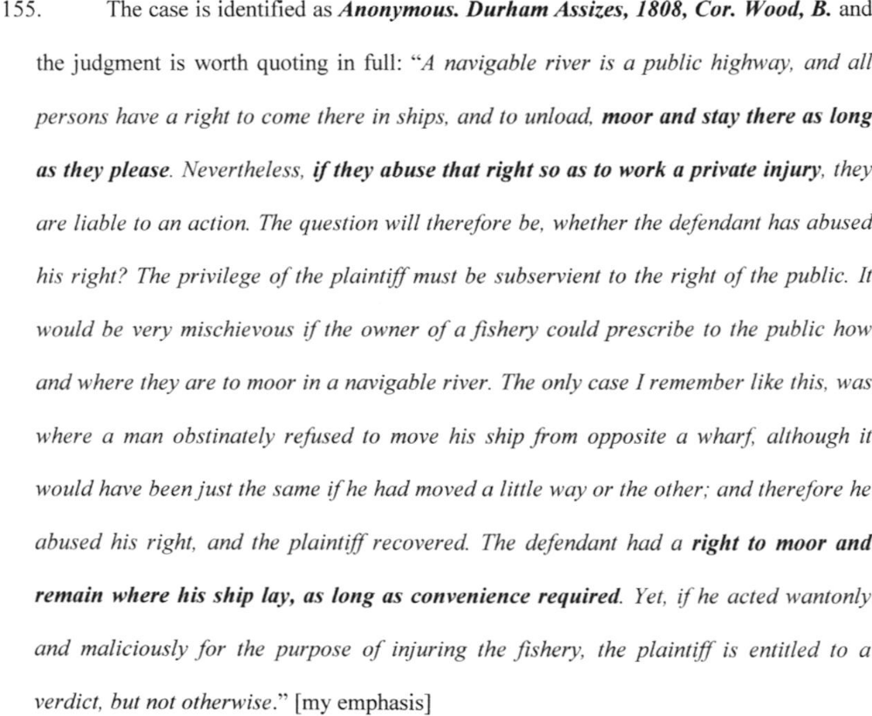

This case, and this principle, was cited again and again in subsequent cases reaching the highest courts in the land, and in Treatises on the law from both sides of the Atlantic. It holds true still.

Roman [Civil] Law

The US State of Louisiana is one of those rare places where a bi-judicial system reigns. This curiosity arose from the original ownership of the area by Spain, who imposed Alphonso’s “Las Siete Partidas” as the governing code of law based on Justinian [Roman] law. The English common law departs from this Code in certain significant elements; notably, from our perspective, in the rights of navigation. Under Roman law public rights extended to the banks, which is very specifically denied under our common law. The Roman-based code survives in Louisiana, however, jointly with the common law system - and its interpretation by the courts, as a consequence of that no doubt, is influenced accordingly.

Thus, in the case of O’Fallon exr. of Mallanphy v Daggett & Price in 1836, respecting the public right of navigation and its impact upon private riparian rights, the same test of reasonable user propounded by Woods, B was applied to the case, with the result that the court held - “that everyone should so use his rights as not to injure or molest others in the enjoyment of theirs, is a maxim that well applies in this case. The Law of the Partidas . . . seems to be an exemplification of the maxim.”

The application to ourselves ought to be obvious – we have rights to do a great many things; we have the right to moor most places, for as long as convenient and/or for as long as is reasonable under particular circumstances – but how we use or abuse those rights will have an effect on the time left wherein such freedom remains in place.
Already the boating community is split between the vocal many who call for more and stricter laws and stricter penalties, and those who might feel that all liberties need to be exercised to be real, and do so careless of the equal rights of others; those in between suffer the consequences already and for so long as such conflicts continue, the more fuel there will be for the authority to play with, and the more likely that at some point, Parliament will once again be approached to legitimise further restraints upon our liberties.

That leads on the next consideration of what this all means to us -

Self-governed reactions

So perhaps we all do the right thing, respect others, move out of the way of watering points and pump-out facilities as soon as we’ve finished with them etc etc – but how does that help, if CART can do nothing about other less sensitive abusers of the system?

In the first place of course, the authority has powers sufficient to solve any such problem by simply shifting an obstructing boat away on the spot without notice – but they are not always around [and as with most bullies, they are reluctant to exercise the reasonable power when they can use an unreasonable one with a whole gang at their back].

In the second place, it is very far from evident that there is any real problem at all – at least for most of the system. Insofar as problems may arise in very localised hot-spots, even then the authority has only become involved because its desire for increased revenue can feed upon perceived complaints. There may be few or none official complaints, but there are certainly screeds of such stuff available on the internet.

Is it appropriate to call for the grant of more powers for CART so that they can threaten offenders with eviction from the waterways on pain of seizure of the boat?

I have no intention of reprising the debate that has been raging under various topic headings in meetings and internet forums; I will just add a twopenn'orth of thought as to the other element to self-recognisance under liberty. Conflicts of the same character have torn apart all sorts of special-interest groups from the dawn of time. The early Christian world was no exception, and provided no legal framework capable of responding to the problem. All it could do was point the way to appropriate individual reactions.

Sometimes, especially if someone you see abusing the system is not personally affecting you, it is better to just leave it be. A number of contributors to the Canalworld Discussion Forum have advocated exactly that - get on with enjoying your own boating without feeling the need to dob somebody else in and so fuelling the fire of a power and money-hungry authority.

Internecine squabbles should be sorted out between yourselves rather than crying to the authority; even if you are inconvenienced on rare occasions, why take action that will adversely affect everyone, just to gratify your wish to punish the inconveniencer?

Paul wrote: “Now therefore there is utterly a fault among you, because ye go to law one with another. Why do ye not rather take wrong? why do ye not rather suffer yourselves to be defrauded? Nay, ye do wrong, and defraud, and that your brethren.”

It’s old advice, but as currently pragmatic as ever was. People living within a libertarian community are well advised to have sufficient flexibility, sufficient give and take, to suffer the occasional fools –i f not gladly, at least sadly, without running to ‘mamma’ to sort it out for us.

What does it mean for us? The responsible anarchist will so behave as to give no occasion to tempt authority to expand its powers; the social dummy-suckers must learn to grow up and leave nanny behind, while those with aspirations of leadership will do well to remember Heinlein’s twist on the saying about “power corrupts” – he said it would be even better observed, that “power attracts the corruptible”.

“Whatever” - as the inelegant modern catch-phrase has it – be reminded that the administering of the canals has always attracted a particular set of characteristics unchanged from the earliest days, and it has to do with the absolutism arising from unassailable authority based on monopoly. That applies to self-administration as well, and yet self-administer we must – armed with the relevant cautions.

In sum – the Appeal Court judgement has affirmed that all things are lawful to us, that are not prohibited at common law or by statute, so that CART have no powers to compel a code of conduct outside of that framework. For harmony to reign without busybodies demanding the imposition of more and more laws to the detriment of our current level of freedom then, those freedoms must be exercised in harmony with the quintessentially just principle of applied law – to repeat the words of the Louisiana court: “Every one should so use his rights as not to injure or molest others in the enjoyment of theirs.”

The way forward

The appalling state of the waterways at present, is signalled by the rats fleeing the sinking ship. It is good that they are going – they have been the architects of the present state of affairs; responsible for perhaps the most parlous physical and financial state of the waterways since the early sixties – and you should remember that the extent of our current canal system owes its existence to bands of volunteers who had to literally and physically face down the attempts of the early BW, to physically and legally prevent all remedial work on the system.

Sadly, there is nothing new about this. It’s worth pausing at this stage to highlight the character of the canal companies of the nineteenth century, all of whom began as virtual monopolies within their spheres of operation. Despite the statutory constraints, their position ensured that their management revelled in unprecedented commercial & therefore social power.

The result was described in “Hogg’s Weekly Instructor” of January 16, 1847 –

“It is not surprising to find these [canal] companies soon monopolising the entire inland traffic of England. The profits they realised are said to be immense. Indeed they appear for many years to have done with the public whatever they listed. Nothing could stand before them. The different canal companies, perceiving a feeble opposition attempted in the way of constructing a few rival lines, formed an extensive combination amongst themselves, and left the public victims to monopoly and exorbitant prices. Long and patiently was this system of extortion supported by the commerce of the country.” . . . “So long as the companies referred to only contented themselves with an exorbitantly high rate of charge, the victims of oppression rested satisfied with a few suppressed and feeble murmurs of dissatisfaction; but when they began to perform the service itself ill and slovenly . . . the indignation of the aggrieved parties was beyond all limits”.

It all sounds so depressingly familiar!
The customers took matters into their own hands back then, as their 20thC equivalents took action in the heyday of the now all but valueless IWA. If the waterways are to be brought back yet again into a decent state of operable life, it will only be as a result of boaters and enthusiasts once again taking matters into their own hands, and also campaigning against the corruption and cupidity of the entrenched executive. The spurious waffle of the BW/CART spin-doctors must be transformed into a meaningful description of practical reality by the actions and demands of those who truly care.

But whether directly or via the influence of a powerful consensus, the future of the waterways lies, as it always has, in your hands alone – and the changing nomenclature of the administration is all but immaterial to that cardinal fact.

Many of the waterways we can enjoy today, exist because groups of individuals did the work of renovation themselves, in the teeth of determined opposition from the authority. However little faith can be placed in the excitable announcements of community opportunities published under the aegis of the present new charity, the opportunity is at least there to undertake the work without the open opposition of yesteryear.

The fact that the laws on use of our waterways are as flexible as they are, is likewise is a thing we owe, and owe heavily, to the groups and individuals who spent years of their lives in front of Parliamentary Select Committees to cut the draconian unpleasantness desired by BW down to a tolerable level of reasonable control. Smarting from their treatment on the 1990 Bill, BW and now CART set about as though they did not need Parliamentary sanction anyway – and that is the situation today that must be countered with everything you’ve got, if we are not to lose what others already fought for so successfully.

The pre-eminent Victorian authority on the Constitution attributed the almost unique libertarian nature of our constitution to the general character of the British people insofar as this is distinct from the general characteristics of other nations – and the continuation of all we hold to be best in this country, is absolutely dependant on retention of that characteristic.

I’d like to conclude with the words of Bagehot on page 197 of his book:

“As far as I can see, the theory of the augmented administrative power of a more democratic government rests not upon an accurate argument, but upon a kind of faith. Sanguine men assume that the English, somehow or another, ought to have the best possible government, and when they find that Parliament is not so decided as they like, they are angry, and clutch at the readiest means of altering Parliament.” – does that ring any bells? – “But it is of little use to alter the suffrage unless we alter ourselves. A free government cannot be wiser than a free nation; it is but their fruit and outcome, and it must be as they are.”

It calls to mind the more succinct phrase coined by someone else – “we all get the government we deserve”.

He concludes that paragraph – “Neither man nor nation can be vigorous except upon a defined and settled creed.”

What that creed should be, you must, and will have to, work out for yourselves.

- - - o o O o o - - -

